Memo
https://owl.purdue.edu/owl/subject_specific_writing/professional_technical_writing/memos/format.html
https://owl.purdue.edu/owl/subject_specific_writing/professional_technical_writing/memos/sample_memo.html
https://www.doc.wa.gov/corrections/covid-19/docs/2021-0308-ratcliff-staff-memo-covid-19-update-for-hbr-work-release.pdf
https://www.coursehero.com/study-guides/technicalwriting/memos_-purpose-and-format-2/
Claims and adjustment Sample Letters (buX)
Adjustment Letter: How to Write (Format) With Examples (doctemplates.net)
8.5: Goodwill Messages and Recommendations – Communication at Work (pressbooks.pub)
9+ Sample Claim Letters - Writing Letters Formats & Examples (sampleletterword.com)
49 Free Claim Letter Examples - How to Write a Claim Letter? (templatelab.com)
Order Letter Sample | Purchasing - Englet
Free Business Meeting Minutes Template | Sample - Word | PDF – eForms
10 Free Meeting Agenda Templates | Word and Google Docs (vertex42.com)
Order:
Order Letter Sample | Purchasing - Englet
Order Letter Sample and Order Confirmation Letter Sample (businesscommunicationarticles.com)

Chapter 7 sample letters

https://blogs.ubc.ca/engl301-99a-2019wa/2019/11/27/business-letters-complaint-and-adjustment-letters/

1. Routine request (inquiry)

Subject: Inquiry about SkyRoom for March 25

Dear Mr. Peterson:

Would you please provide information regarding the banquet facilities for SkyRoom. We are considering holding our annual awards luncheon for 265 of our personnel at your hotel on March 25. Our decision will be based on answers to the following questions:

1. Is your facility available from 9 a.m. until 3 p.m. on that date? We will need the additional time for setup and takedown.
2. Do you offer free use of audiovisual equipment? We would need a color projector and screen. We would supply the portable computer.
3. Do you have a variety of hot lunches that can be served tableside for between $15 and $18, including tax and gratuities?

We look forward to having this information in time for us to make our site selection by January 15. Please let us know in a return email or you may contact via phone using our direct landline, +1-408-227-5438.

Sincerely,
Olson Green
Notes: The above request is an email. Try to relate this sample with the Pralie Realty (good news example PDF). The first sentence makes the request in polite question form minus the question mark. Itemize questions. Ask the most important question first..Ask only relevant questions. Try to deal with one topic per question.
The subject in the original was ‘Request for information About Banquet Facilities’. What do you think about the change ‘Inquiry about SkyRoom for March 25’?
The original ending was ‘Thank you for providing this information in time for us to make our site selection by January 15’. What do you think about the new ending ‘We look forward to…….5438’?
The email uses the direct approach. The ending is courteous and specific (the sender expects a quick response).

2. Routine reply

Subject: Your January 3rd Inquiry about SkyRoom

Dear Mr. Green:

Yes, we would enjoy hosting your awards luncheon on March 25. Our SkyRoom, which has a lovely view of the Cleveland skyline, is available until 4 p.m. that day.
To offer round-the-clock service, we have contracted with an outside firm to provide all audiovisual services for a fee of $300 for the entire day. You may make arrangements directly with GuestServe by calling the company at 555-1086.

For the health-conscious guest, we offer soup-and-salad lunches for between $12 and $18. We also offer a hot buffet line with your choice of two main dishes for between $16 and $20. Hot meals served tableside begin at $21.75 for our popular braised chicken breast.

No matter what your choice, you will find that our facilities, food, and service live up to the “Cleveland’s finest” label recently awarded to us by Cleveland Monthly magazine. Please call me at 555-3288 for further booking and formalities. We hope to serve your organization well.

Sincerely,
Robin Peterson
Notes: The original subject was ‘Hosting Your Awards Luncheon’. What do you think about the subject change (is it better)? The reply also uses the direct approach. The ending is goodwill talk. Think of the other points discussed in class- the budget (between $15-18/person) and the reply. The reply is positive. Also, use of the “you” attitude.

3. Routine Claim Letter
Dear Ms. Pearson:

Subject: Request for Valet-Parking Refund

Would you please issue Franklin Associates a refund check for $426 to fix an incorrect charge for valet parking at a luncheon we held at the Berkshire on March 25.
We paid your Invoice 3042 for $8,012 with our Check No. 941386. Upon reviewing your invoice, however, I noted a $426 charge for valet parking for 213 vehicles at $2 each.

Our contract with you states that “complimentary valet parking will be provided for all catered events with a total food and beverage charge of at least $7,500.”
I have enclosed copies of your invoice, our check, and the contract. Thanks for taking care of this matter and for a truly memorable meal. Everyone is still talking about your delicious mile-high pie.
Sincerely,
Henry Olson
4. Routine Adjustment Letter
Dear Mr. Olson:
Subject: Your Refund Check for $451.56

Thanks for giving us the opportunity to correct our bill. The enclosed check for $451.56 represents a refund of the valet parking bill of $426 plus $25.56 tax.
As you will remember, the day before your luncheon, you gave us a head count of 268 guests, which resulted in a bill of $7,420—below the $7,500 minimum for free parking.

Although we were happy to accommodate the eight extra guests who showed up without reservations, we inadvertently failed to note that they brought your total bill above the minimum required for free parking.

I appreciate your calling this matter to our attention, Mr. Olson, and look forward to serving you and your colleagues another slice of our famous mile-high pie in the near future.
Sincerely,
Elizabeth Pearson

5. (a) Poorly written adjustment grant
Subject: Your broken, damaged London lights
Mr. Anderson,
We have received your May 1 claim reporting that our shipment of London lamp post lights reached you with 15 broken units. We regret the inconvenience caused to you and understand your unhappiness.
Apparently the fault is the result of an inexperienced temporary employee’s negligence. We have taken corrective measures to assure that future shipments will be packed more carefully.
I am pleased to report that we are sending the replacements today. They should reach you before the end of this week. Our delivery man will pick up the broken units when he makes delivery.
Again, we regret all the trouble caused you.
Theresa Smith.
Notes: Is the subject problematic? What about the salutation? The sender is blaming a temporary employee-does it look professional? The second last paragraph mentions pickup of the broken units- is it alright to include this? The ending acts as a reminder of what the receiver had to go through. The good news is delayed by 2 paragraphs (sending replacements). This email uses a negative approach.
5. (b) Better version of the adjustment grant sample letter
Subject: Your May 1 report on invoice 1248
Dear Mr. Anderson,
Seventeen carefully packed Old London lamp posts should reach your sales floor in time for your Saturday program. Our delivery man left our warehouse to deliver them to you on Friday.
Because your satisfaction with our service and products is our top priority, we have thoroughly checked our shipping procedures. It appears that the shipment was packed by a temporary employee replacing a veteran packer. We now have our veteran packer back at work.
As you know, the Old London lamp post lights have become one of the hottest products in the lighting field. We are confident that they will play their part in the success of your sale.
Theresa Smith

· Fostering Goodwill

1.Congratulating someone- Taking note of significant events in someone’s personal life.
2.Sending a message of appreciation- An effective message of appreciation documents a person’s contributions. Your praise does more than just make the person feel good; it encourages further excellence. Sample:
Thank you and everyone on your team for the heroic efforts you took to bring our servers back up after last Friday’s flood. We were able to restore business right on schedule first thing Monday morning. You went far beyond the level of contractual service in restoring our data center within 16 hours. I would especially like to highlight the contribution of networking specialist Julienne Marks, who worked for 12 straight hours to reconnect our Internet service. If I can serve as a reference in your future sales activities, please do not hesitate to ask.
3.Offering condolences-The primary purpose of condolence messages is to let the audience know that you and the organization you represent care about the person’s loss.

Chapter 8 sample letters
1. Refused Request (Direct Refusal)
Subject: Your request for donation
Dear Ms. Cangelosi:
We regret to inform you that we cannot grant your request for a donation to the association’s scholarship fund.
So many requests for contributions are made to us that we have found it necessary to budget a definite amount each year for this purpose. Unfortunately, our budgeted funds for this year have been exhausted, so we simply cannot consider additional requests. We won’t be able to consider your request until next year. However, we will be able to consider your request next year.
We deeply regret our inability to help you and trust that you understand our position.
Mark Stephens

2.Refused Request (Indirect Refusal)

Subject: Your Scholarship Fund Request
Dear Ms. Cangelosi:
Your efforts to build the scholarship fund for the association’s needy children are commendable. We wish you success in your efforts to further this worthy cause.
White Label Industries assists worthy causes whenever we can. We at White Label Industries are always willing to assist worthy causes whenever we can. That is why every January we budget for the year the maximum amount we are able to contribute to such causes. Then we distribute that amount among the various deserving groups. Since our budgeted contributions for this year have already been made, we are placing your organization for consideration on next year’s waitlist (we are placing your organization on our list for consideration next year).
We wish you success in your efforts to improve the lives of the children in our city. If you wish to contact us further for other queries for next year’s waitlist, emails are the best way to reach us. Until then we wish you the best of luck Ms. Cangelosi in your efforts to help educate the deserving children of the association.
Regards,
Mark Stephens
3. Credit Denial (Harshness as a Result of Tactless Treatment)
Subject: Your Credit request
Dear Mr. Bell:
We have received your May 3 order and accompanying request for credit. After carefully reviewing the financial information you submitted, we regret to report that you do not meet our requirements for credit. It is our judgment that firms with your weak assets-to-liabilities ratio should be performing better if buying with cash. Thus, we encourage you to do so.
We would, of course, be pleased to serve you on a cash basis. We sincerely regret that we must deny you credit at this time.
Terrence Patrick
4. Credit Denial (Courtesy and Tact in a Clear Refusal)
Subject: Your Credit request
Dear Mr. Bell:
Your May 3 order for Pinnacle paints and supplies suggests that your company is continuing to make good progress. As you may know, most financial experts say that maintaining a 2:1 ratio of current assets to current liabilities is a good minimum. With the belief that this minimum ratio is best for all concerned, we extend credit only when it is met. As soon as you reach this ratio, we would like to review your application again. Meanwhile, as always we will strive to meet your needs on a cash basis.
If you have other banking related queries, please feel to contact our support manager Mr. Allen Smith at +408-338-5678 through Mondays to Fridays between 10 am to 4 pm. We appreciate your interest and look forward to serving you.
Sincerely,
Terrence Patrick

5. Adjustment Refusals (Direct Refusal)
Subject: Your May 3 claim for damages
Ms. Sanderson,
I regret to report that we must reject your request for money back on the faded Do-Craft fabric.
We must refuse because Do-Craft fabrics are not made for outdoor use. It is difficult for me to understand how you failed to notice this limitation. It was clearly stated in the catalog from which you ordered. It was even stamped on the back of every yard of fabric. Since we have been more than reasonable in trying to inform you, we cannot possibly be responsible.
We trust that you will understand our position. We regret the damage and inconvenience our product has caused you.
Marilyn Cox
Customer Relations
6. Adjustment Refusals (Indirect Refusal)
Subject: Your May 3 report about Do-Craft fabric
Ms. Sanderson,

Certainly, you have a right to expect the best possible service from Do-Craft fabrics. Every Do-Craft product is the result of years of experimentation. And we manufacture each yard with careful control. We believe that our products will do for you what we say they will do.

Because we do want our fabrics to please, we carefully inspected the photos of Do-Craft Fabric 103 you sent us. It is apparent that each sample has been subjected to long periods in extreme sunlight. We have known from the beginning that Do-Craft fabrics cannot withstand exposure to sunlight which we have clearly noted in all our advertisements. It is also featured in the catalog from which you ordered and in a stamped reminder on the back of every yard of the fabric. Under the circumstances, all we can do concerning your request is suggest that you change to one of our outdoor fabrics. As you can see from our catalog, all of the fabrics in the 200 series are recommended for outdoor use.
You may also be interested in the new Duck Back cotton fabrics listed in our 500 series. These plastic-coated cotton fabrics are economical, and they resist sun and rain remarkably well. If we can help you further in your selection, please contact us at service@pinnacle.com.
Regards,
Marilyn Cox
Consumer Relations

7. Refusing requests for employment references and recommendation letters

7. (a) Our human resources department has authorized me to confirm that Yolanda Johnson worked for Tolson Logistics for three years, from June 2014 to July 2016. Best of luck as you interview applicants.

7. (b) Any refusal to cooperate may seem to be a personal slight and a threat to the applicant’s
future. Diplomacy and preparation help readers accept your refusal:

Thank you for letting me know about your job opportunity with Coca-Cola. Your internship there and the MBA you’ve worked so hard to earn should place you in an excellent position to land the marketing job.
Although we do not send out formal recommendations here at PepsiCo, I can certainly send Coca-Cola a confirmation of your employment dates. And if you haven’t considered this already, be sure to ask several of your professors to write evaluations of your marketing skills.
Best of luck to you in your career.

8. Rejecting job applications

Dear Ms. Anderson:

Thank you for considering Johnson & Jackson as a place to launch your career in accounting. After a careful review of all the applications we received for this position, your application was not among those selected for an interview.

We appreciate your interest and I encourage you to apply again if a compatible job opening is posted on our website in the future.

Best wishes for success in your career.

Sincerely,

Henry A. Fletcher
HR Director
Johnson & Jackson
Chapter 9
Persuasive Message Using the AIDA Model Randy Thumwolt uses the AIDA model in a persuasive memo about a program that would try to reduce Host Marriott's annual plastics costs and try to curtail consumer complaints about the company's recycling record. Note how Thumwolt "sells the problem" before attempting to sell the solution. Few people are interested in hearing about solutions to problems they don't know about or don't believe exist. His interest section introduces an additional, unforeseen problem with plastic product containers. See the picture below:
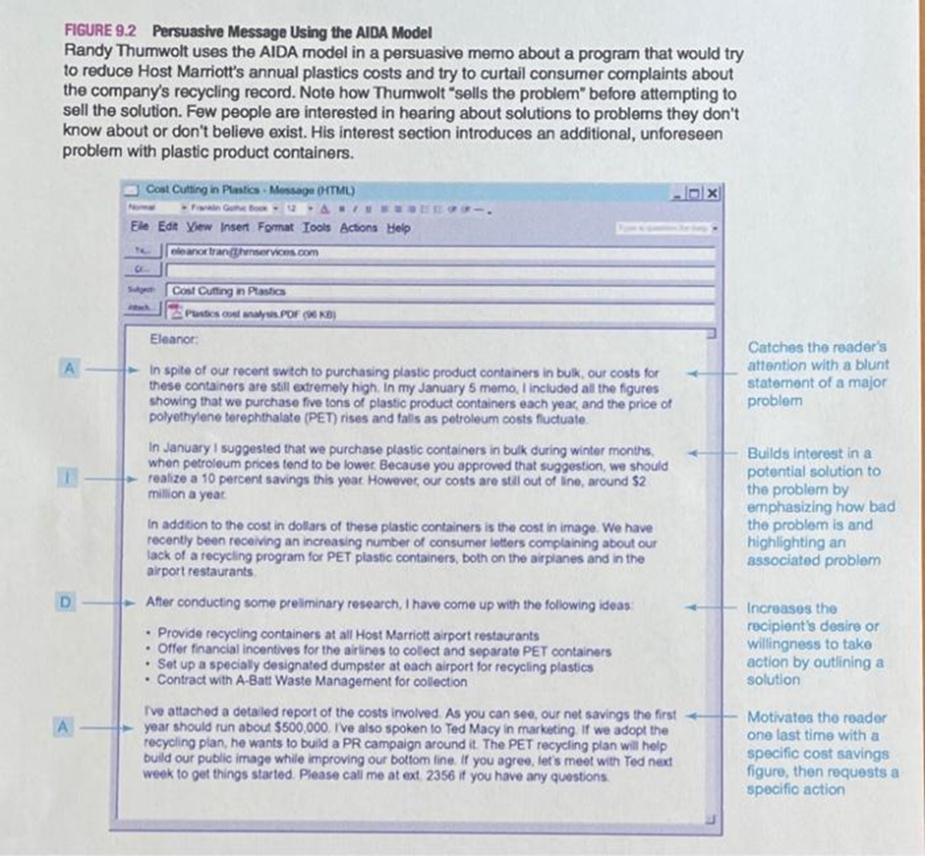

Sample 2:
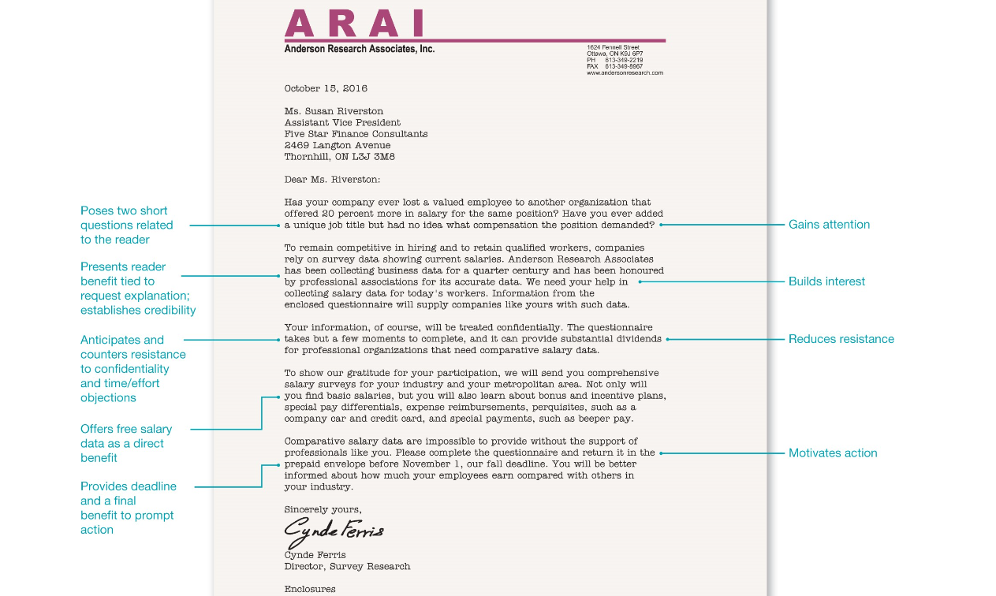
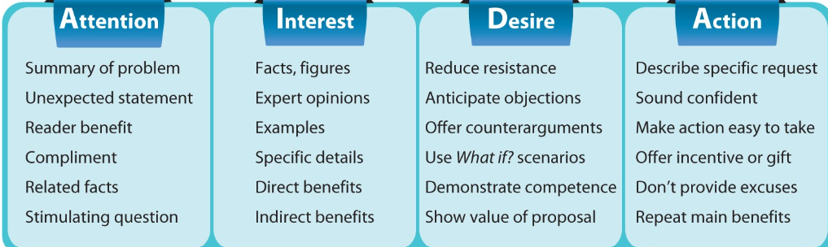

Format

- Letter:

Sender’s Full Name
Job Title/position
Company Name
Address

Date

Recipient’s full name
Job Title
Company name
Address

*Subject:

Dear Mr./Ms. Surname: .
.

.
.

.
.

Closing (Sincerely,/Regards,/etc)

Signature

Full Name

*Please note that the subject can come after the salutation but for uniformity we are including it before the salutation **Also note, that you can exclude the sender’ name, position and company name if you share these after the closing. For example:

House 7, Road 14
Dhanmondi 5A
Dhaka 1207

November 10, 2023

Zaima Ahmed
Marketing Manager
Berger Paints
House 5, Road 82
Gulshan 2, Dhaka 1212

Subject:

Salutation

…

..

…

Sincerely,

Signature

Sabah Huq
Procurement Manager
Transcom Group

